|  |
| --- |
| Good Counsel college |
| The Sharemarket |
| Report for Client |
|  |
|  |
| |  |  | | --- | --- | | **Prepared by:** | James Macgillivray | | **Date Prepared:** | Monday 12 September 2022 | |

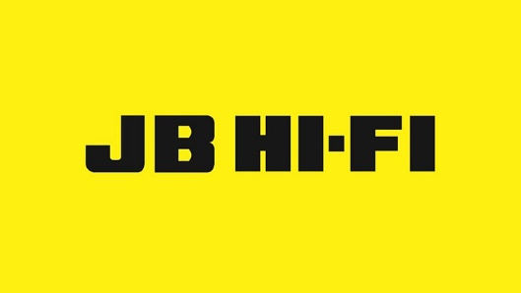

**Introduction**

The purpose of this report is to recommend a company to the client from the ASX which would be a good investment. It would be a successful recommendation if it accrues a significant amount of money over a period in either dividends or rising share price. It will also compare that company to another in its industry.

**PART A outline of ASX Sharemarket company**

The company chosen as an investment is JB Hi-Fi. It is a consumer electronic and white goods retailer with stores around Australia. Its head office is in Southbank Victoria and has stores in Australia and New Zealand. It was founded in 1974 by John Barbuto as a single store business and the sold it in 1983 who expanded the company to ten stores . Throughout the 2000s, it bought a competing consumer goods store and converted them into JB Hi-Fi stores (About JB Hi- Fi, 2022). It was first listed on the Australian Stock Exchange in 2003. In 2016 the company then bought another competing company “The Good Guys” making it the 7th largest company in its industry (About JB Hi- Fi, 2022).

**PART B Performance of the company**

The share price of JB Hi-Fi Limited fluctuated significantly over the past six months. Figure 2 in the Appendix shows the price history over that period. The share price starts high in April with a high of $57 and declines 36% over the next three months to $36. Since then, it has risen 16% in the previous three months to where it now at $42.

**PART B performance of a similar company**

The share price of Harvey Norman Holdings Limited fluctuated significantly over the past six months. Figure 1 in the Appendix shows the price history over that period. The share price starts high in April with a high of $5.75 and declines %38 over the next 3 months to $3.60. It has since risen from that low and is slowly rising for the previous 3 months to where it rose 20% and is now at $4.30. Both companies share a very similar price history graph, almost mirroring each other over the past six months.

**PART C Analysis of companies**

The companies of JB Hi-Fi Limited and Harvey Norman Holdings Limited, like all companies, are affected by market influences and world events. The Covid-19 pandemic has decreased in-store visits but increased online purchasing. A very high inflation rate is also influencing the market currently. This is causing high stock price volatility, however since the currency is inflated the true returns on stocks decrease (Zucchi, 2022). On the 15th of, JB Hi-Fi released an annual financial report for the business. This was used to create excitement around the company itself and caused a small price increase for the stock. Recently on the 25th of August the share price of JBH dropped substantially. This was not caused by a world event nor an announcement from the company, but the fact that it was the ex-dividend date and many investors wanted to sell their stake in the company (Teboneras, 2022). The ex-dividend date meant that because they were paid the dividend on that date of 7.71%, they wanted to sell at that point rather than a different time. This did not however impact Harvey Normans stock price due to its ex-dividend date earlier in the year its share price too recently dropped, this just seems to follow the current trend of the ASX which has been falling over this past month. Harvey Norman released that in the 2021 financial year they had a revenue exceeding 10 billion dollars (Aggregated Sales Revenue, 2022). This however did not seem to affect the stock price as it continued to mirror the JB Hi-Fi stock price.

|  |  |
| --- | --- |
| Name of Business: JB Hi-Fi | Impact on the business |
| Positive findings  -JB Hi-Fi full year results report  -High dividend price | This report reassured investors that the business is continuing to grow and increased the share price temporarily  This creates some guaranteed income from the stock |
| Negative findings  -Ex-dividend date | This resulted in many investors selling their stocks, causing the stock price to fall temporarily |

|  |  |
| --- | --- |
| Name of Business: Harvey Norman | Impact on the business |
| Positive findings  -Revenue reached 10B over 2021 | Caused news articles to discuss this milestone resulting in more market interest |
| Negative findings  -High Inflation | This created volatility in the stock price for both companies |

**PART D Recommendations**

After looking at the evidence, it seems that JB Hi-Fi is currently a good investment opportunity. Past performance does not mean future performance, so making definitive claims about how the market will react in the future is a poor decision. However, it does seem reasonable to assume that JB Hi-Fi and the ASX in the next six months would rebound from its current slump and create a decent net profit. This if true would mean that investing in JB Hi-Fi would be superior to Harvey Norman as it is currently more expensive in its cycle as seen in figure 1 and 2. Even so, it would be a bad investing decision to invest all of one’s portfolio into just one stock, as it is very important to diversify in different markets to avoid losing substantial amounts of wealth over time.

**Reference list**

About JB Hi-Fi (2022). JB Hi-Fi. https://www.jbhifi.com.au/pages/about-us

Aggregated Sales Revenue For The Year Ended 30 June 2022 (2022). Harvey Norman. http://clients.weblink.com.au/news/pdf/02561663.pdf

Teboneras, A. (2022). Why is the JB Hi-Fi share price slumping today? https://www.fool.com.au/2022/08/25/why-is-the-jb-hi-fi-share-price-slumping-today/

Zucchi, K. (2022). Inflation's Impact on Stock Returns. https://www.investopedia.com/articles/investing/052913/inflations-impact-stock-returns.asp

**Appendix**

**Figure 1: Performance of Harvey Norman from May to September 2022**

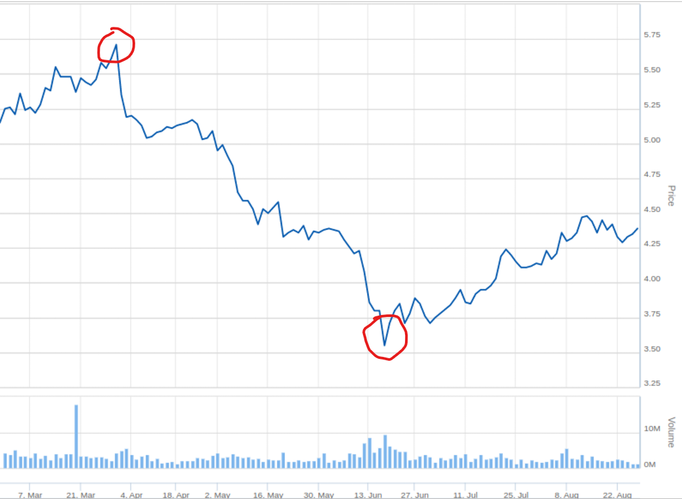

**Figure 2: Performance of JB Hi-Fi from May to September 2022**

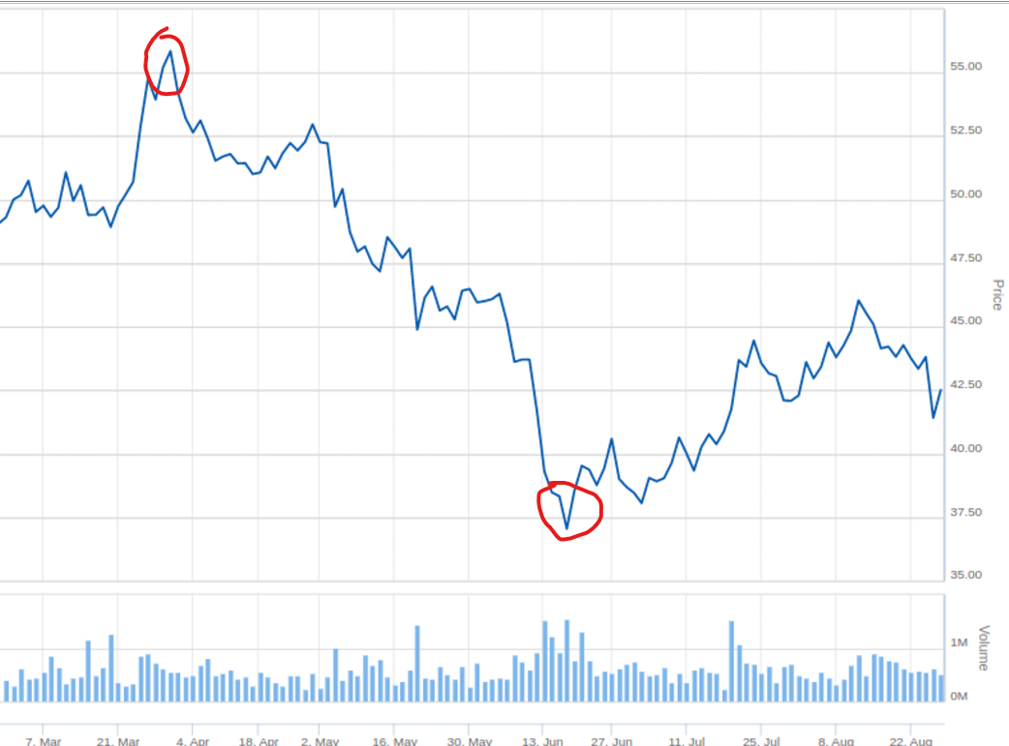

**Table 1: Tracking Table of Harvey Norman**

|  |  |  |  |  |
| --- | --- | --- | --- | --- |
| Week | Date | | Last price | Price change |
| 7 | 22 | Aug | 4.33 | - |
| 24 | Aug | 4.33 | - |
| 26 | Aug | 4.39 | +0.06 |
| 8 | 29 | Aug | 4.21 | -0.18 |
| 31 | Aug | 4.23 | +0.02 |
| 2 | Sep | 4.17 | -0.06 |
| 9 | 5 | Sep | 4.20 | +0.03 |
| 7 | Sep |  |  |
| 9 | Sep |  |  |

**Table 2: Tracking Table of JB Hi-Fi**

|  |  |  |  |  |
| --- | --- | --- | --- | --- |
| Week | Date | | Last price | Price change |
| 7 | 22 | Aug | 43.77 | - |
| 24 | Aug | 43.81 | +0.04 |
| 26 | Aug | 42.51 | -1.03 |
| 8 | 29 | Aug | 40.51 | -2.00 |
| 31 | Aug | 40.69 | +0.18 |
| 2 | Sep | 39.47 | -0.99 |
| 9 | 5 | Sep | 40.15 | +0.68 |
| 7 | Sep |  |  |
| 9 | Sep |  |  |